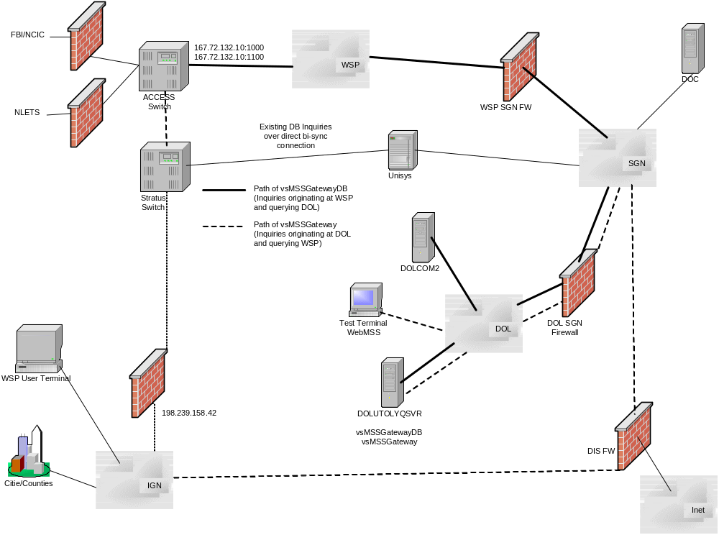
Internetwork Environment

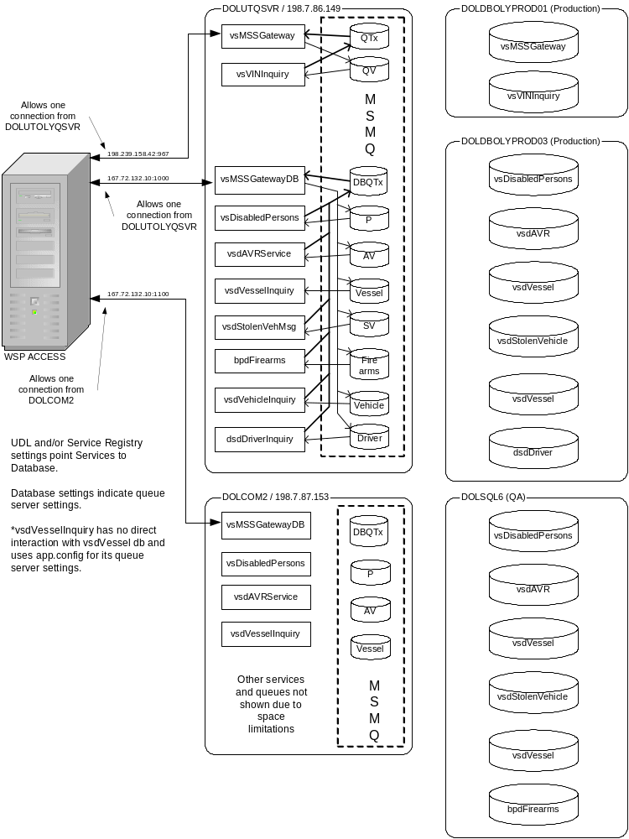
WSP – DOL Queue Environment

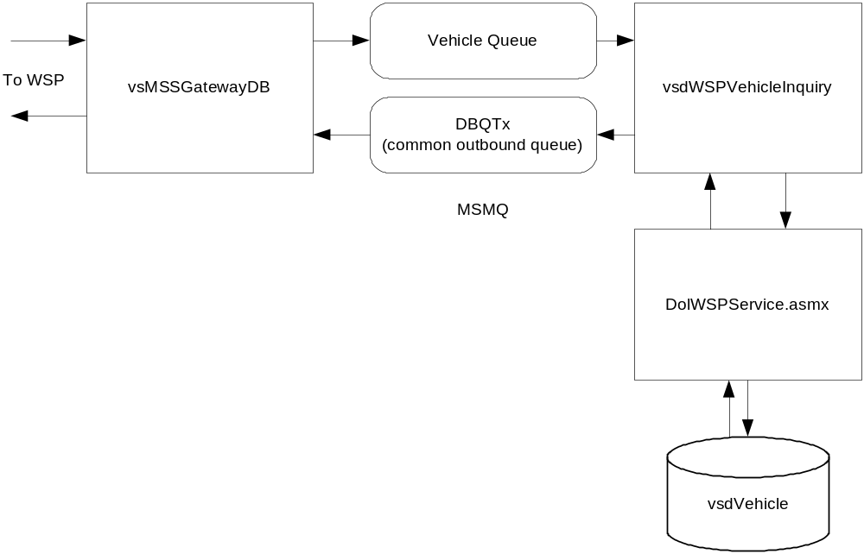
Message Transaction Flow

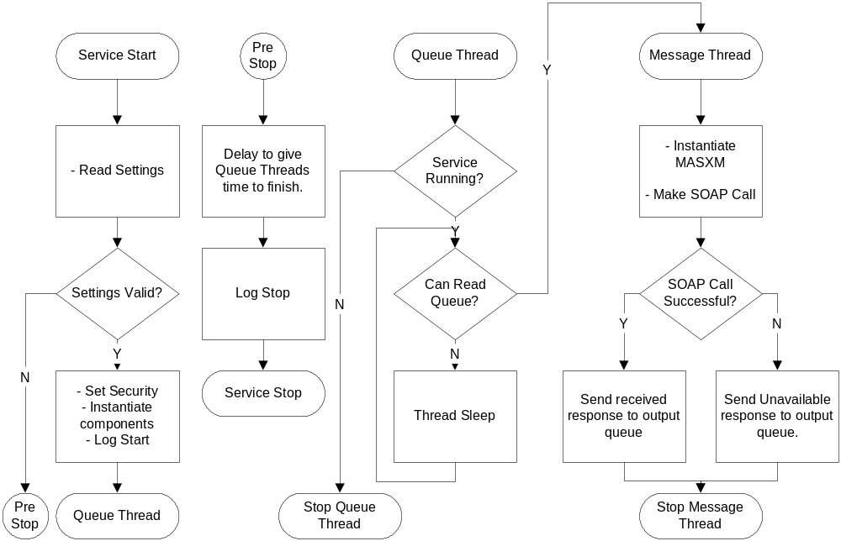
Code Flow
Appendix A –Installation

1. Run the script vsMSSGateway_Vehicles.sql on DOLDBOLYPROD01 to add the Vehicle queue to the queue list.

2. Manually create a “Vehicle” queue on the queue server cluster.

3. Stop the vsMSSGatewayDB on queue server cluster.

4. Re-start the vsMSSGatewayDB on the queue server cluster (this registers the new vehicle queues)

5. Migrate the following files from DOLCOM2 to the desired location on queue server cluster:

vsdWSPVehicleInquiry.exe
vsdWSPVehicleInquiry.exe.config
WA.DOL.VSD.WSPQueue.dll
vsdWSPVehicleInquiry_Keys.reg

6. Register the EXE as a Windows service using:

c:\windows\Microsoft.net\framework\<most recent version>\InstallUtil.exe <step 5 path>\vsdWSPVehicleInquiry.exe

7. Import the additional registry keys by double-clicking the file "vsdWSPVehicleInquiry_Keys.reg"

8. Configure the "WSP Vehicle Inquiry" service to log on using the DOL_RSRC\WSPGATEWAY account.

9. Modify the “QueueServer” key value of the vsdWSPVehicleInquiry.exe.config file to use queue server cluster as shown below:

<add key="QueueServer" value="DOLUTOLYCLSTR02"/>

10. Verify the “User”, “Password”, “Domain”, and “UseSystemCredentials” parameters are as shown below:

<add key="User" value=""/>
<!-- password -->
<add key="Password" value=""/>
<!-- domain -->
<add key="Domain" value=""/>
<!-- UseSystemCredentials -->
<add key="UseSystemCredentials" value="True"/>

11. Modify the “WebServiceURL” key value of the vsdWSPVehicleInquiry.exe.config file to point to the URL of the backend Production Fujitsu web service page “dolWSPservice.asmx”, such as:

<add key="WebServiceURL" value="https://dolservice.dol.wa.gov/dolWSPService.asmx"/>

Note – use HTTP or HTTPS as necessary depending upon whether the certificate is installed.

12. Verify the F5 and web application at http://dolservice.dol.wa.gov/dolWSPService.asmx allows HTTP(S) requests from the queue servers to port 80 and/or 443, depending upon whether the certificate is installed.
13. Set the permissions to allow the vsdWSPVehicleInquiry process and/or the WSPGateway user account to have read and write access to the DBQTx and Vehicle queues in the queue cluster.

14. Start the "WSP Vehicle Inquiry" service. See Appendix C for Troubleshooting tips.

15. See Appendix B for testing of the vsdWSPVehicleInquiry service.

Appendix B –Testing
vsdWSPVehicleInquiry – in order to test the vsdWSPVehicleInquiry, the T, V, and L message keys need to be configured on the WSP ACCESS switch to use the DOLDB (database) connection. Contact Al Riehl at Al.Riehl@wsp.wa.gov or 360-705-5357 for activation. Note – Al prefers 10 days notice of message key activation and generally only makes changes M-F during business hours.

Once the ACCESS switch is configured to use the DOLDB connection, go to a WSP Test Terminal and execute the below steps to submit test inquiries:

1. Open Internet Explorer
2. Enter the following URL

http:access.wsp.wa.gov
3. Select the "Non-WSP WebMSS Terminal - (IGN)" link.

To use the WSP test terminal:
1. Logon by typing ON.ACCESS.USER and then clicking the "Send" button.
2. Enter the desired inquiries using the following format (note – only enter one at a time):

D;L.. <insert plate here>
D;V..<insert VIN here>
D;T..<insert YY of year + vehicle tab here>

Examples:
D;L..003LLR
D;V..PDPVEHICLE12005
D;T..00DV00255

3. Click "Send" to send an inquiry.
4. Wait until the lower left "NORM" lights up in red. Click the Receive button
to receive the response.
5. When finished, be sure to log off of the WSP ACCESS switch by typing "OFF" and clicking "Send" before closing the browser.

Appendix C – Troubleshooting
vsWSPVehiclelInquiry Windows Service
If the vsWSPVehicleInquiry fails to start.
- Verify the logon account information for the service is correct per step 8. Also verify the specified user belongs to the local users group for the target machine and has log on as service rights.
- The vsdWSPVehicleInquiry service relies on the WA.DOL.LogEvent component. The WA.DOL.LogEvent component relies on the WA.DOL.SendMail and WA.DOL.Data components. Each of these components must be successfully installed in the GAC and running under COM+.
  - Verify each component has its appropriate .config file in the GAC location as described in Appendix A. The System Event log will show a .NET Runtime error if missing.
  - Verify each component tests successfully using the scripts described in their installation document. The System Event log will show a .NET Runtime error for the specified component which may provide additional troubleshooting tips such as missing .config files.
  - Verify each COM+ application is configured to run under the WSPGATEWAYUSER resource account as described in their respective installation document. If the components are set to run interactive and no user is logged in, the service will fail to start. The System Event log will show a .NET Runtime error.

If the vsdWSPVehicleInquiry fails to read messages from the queue.
- Verify the queues exists on the appropriate server and that the vsdWSPVehicleInquiry.exe.config file points to the appropriate queue server via the QueueServer key.
- Verify the ADODB.DLL is installed in the GAC. By default, ADODB is installed in the GAC for developer workstations, but not .NET framework only machines.
- Verify the queues have the appropriate read/write access that allows the service to read and write to the queues.

